**BỘ GIÁO DỤC & ĐÀO TẠO**

**TRƯỜNG ĐẠI HỌC SƯ PHẠM KỸ THUẬT TP. HỒ CHÍ MINH**

**KHOA ĐIỆN – ĐIỆN TỬ**

**BỘ MÔN TỰ ĐỘNG ĐIỀU KHIỂN**

**-----------------⸙∆⸙-----------------**



**WEEKLY REPORT**

**TOPIC: APPLYING MATLAB IN SURVEYING THE QUALITY OF A SYSTEM**

**GVHD: Trần Đức Thiện**

**SVTH: Trần Minh Quân**

**MSSV: 19151078**

**Tp. Hồ Chí Minh ngày 13 tháng 03 năm 2022**

Contents

1. Requirement 3

2. Solution 4

2.1 Transfer function of the heat furnace 4

2.2 Zeigler - Nichols 4

2.3 Building a closed-loop temperature control model 5

2.3.1 Surveying system with controller P(Ki=0, Kd=0). Find overshoot, setting error, and transient time: 6

2.3.2 Surveying system with controller PI(Kp=0.024, Kd=0). Find overshoot, setting error, and transient time: 6

2.3.3 Surveying system with controller PD(Kp=0.024, Ki=0). Find overshoot, setting error, and transient time: 7

Figure 1: Characteristic of a furnace 3

Figure 2: Open-loop system for a heat furnace 3

Figure 3: Close-loop system for a heat furnace 3

Figure 4: Characteristic of a heat furnace 4

Figure 5: Zeigler-Nichols 1st method 5

Figure 6: Step response of the system using P controller 6

Figure 7: Step response of the system using PI controller 6

Figure 8: Step response of the system using PD controller 7

# Requirement

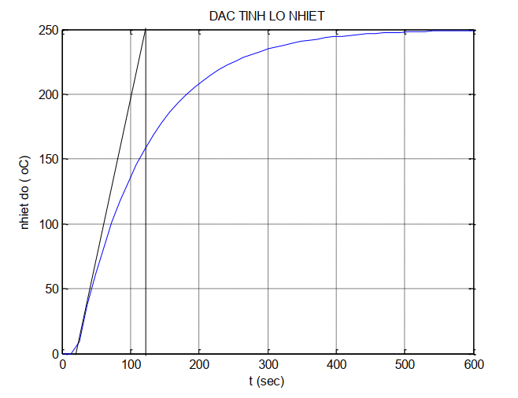

Figure 1: Characteristic of a furnace

1. Determine the approximate transfer function of the above characteristic
2. Used Simulink to build an open-loop system of a heat furnace

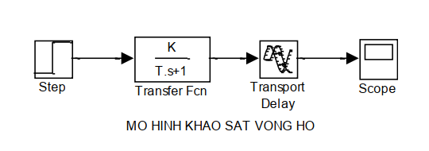

Figure 2: Open-loop system for a heat furnace

1. Design the PID controller for a heat furnace using Zeigler-Nichols’s method.
2. Build the model to control the temperature using the figure below.

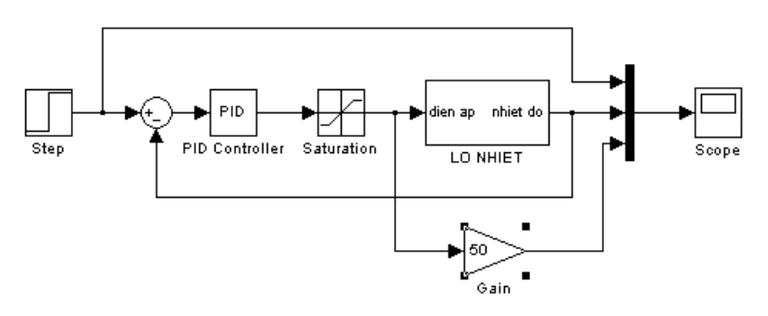

Figure 3: Close-loop system for a heat furnace

Then survey the system using the controller P(Kp vary,Ki=Kd=0); PI(Kp=0.024,Ki vary,Kd=0); PD(Kp=0.024,Ki=0,Kd vary)

# Solution

## Transfer function of the heat furnace



Figure 4: Characteristic of a heat furnace

Transfer function of the furnace:

|  |  |
| --- | --- |
| $$TF= \frac{K}{(T_{1}s+1)(T_{2}s+1)}$$ | (1.1) |

Note:

T1: time delay.

T2: time constant on the furnace.

From the characteristic of the furnace, we can determine the following parameters

|  |  |
| --- | --- |
| $$T_{1}=15s$$ | (1.2) |
|  |  |
| $$T_{2}=115s$$ | (1.3) |
|  |  |
| $$G\left(s\right)= \frac{K}{\left(T_{1}s+1\right)\left(T_{2}s+1\right)}=\frac{250}{(15s+1)(115s+1)}$$ | (1.4) |

## Zeigler - Nichols

PID controller:

|  |  |
| --- | --- |
| $$G\left(s\right)= K_{p}(1+\frac{1}{T_{i}s}+T_{d}s)$$ | (1.5) |

Applying Zeigler-Nichols 1st method we have:

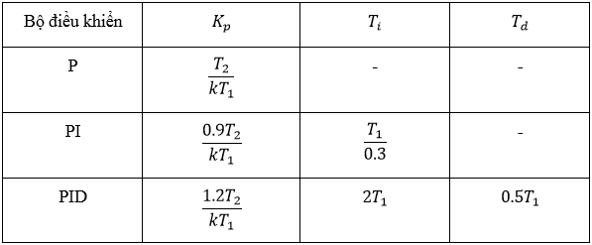

Figure 5: Zeigler-Nichols 1st method

|  |  |
| --- | --- |
| $$K_{p}=\frac{1.2T_{2}}{{KT}_{1}}=\frac{1.2×115}{250×15}=0.0368$$ | (1.6) |
|  |  |
| $$T_{i}=2T_{1}=2×15=30s$$ | (1.7) |
|  |  |
| $$T_{d}=0.5T_{1}=0.5×15=7.5s$$ | (1.8) |



|  |  |
| --- | --- |
|  | (1.9) |

## Building a closed-loop temperature control model

**Calculation method:**

Tr: steady-state value is the time it takes to respond to the system increasing from 10% to 90% of its steady-state value:

|  |  |
| --- | --- |
| $$T_{r}=C_{xl}×90\%-C_{xl}×10\%$$ | (1.10) |

σmax% or POT: system overshoot.

|  |  |
| --- | --- |
| $$POT=\frac{C_{max}-C_{xl}}{C_{xl}}×100\%$$ | (1.11) |

Exl: System setting error:

|  |  |
| --- | --- |
| $$E_{xl}=C_{req}-C_{xl}$$ | (1.12) |

Txl: Time required for the deviation between the system response and its steady-state value not to exceed 2% or 5%. In the lesson we use the 2% standard.

|  |  |
| --- | --- |
| $$c_{tren}=(1+2\%)*c_{xl}$$ | (1.13) |
| $$c_{duoi}=(1-2\%)*C_{xl}$$ | (1.14) |

### Surveying system with controller P(Ki=0, Kd=0). Find overshoot, setting error, and transient time:

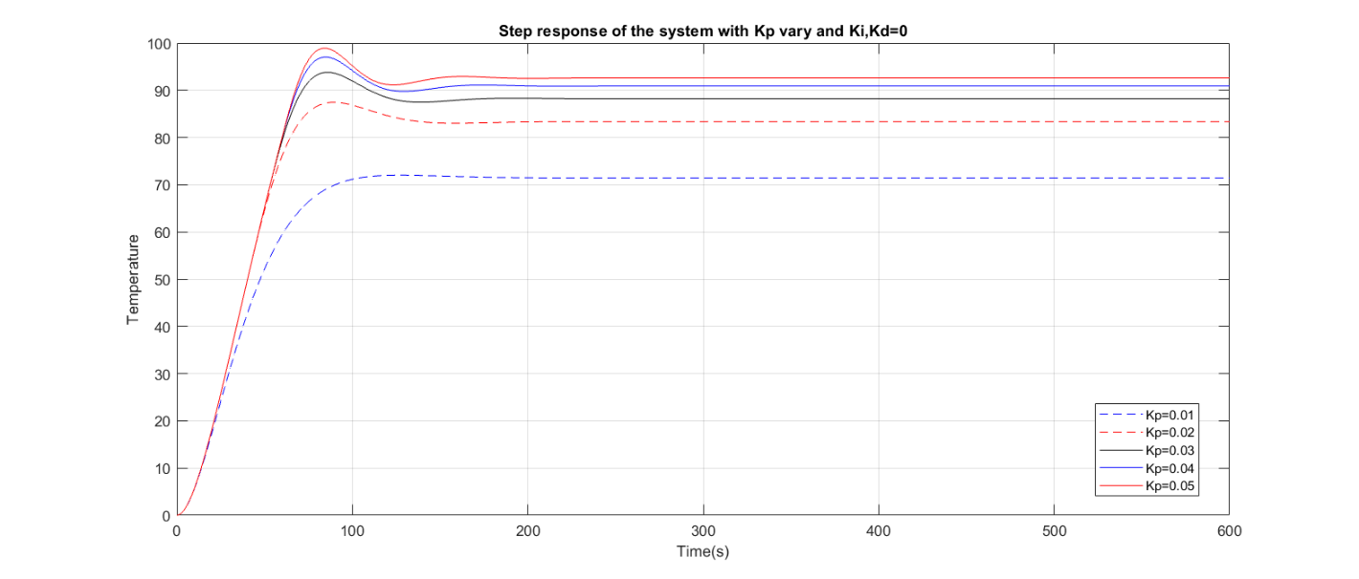

Figure 6: Step response of the system using P controller

|  |  |  |  |  |  |  |
| --- | --- | --- | --- | --- | --- | --- |
| Kp | Overshoot  (%) | Steady State Error | Duration of Response | | | Duration of Steady State |
| 10% | 90% | Duration |
| 0.01 | 0.83 | 28.57 | 11.49 | 69.45 | 57.96 | 95.6 |
| 0.02 | 4.94 | 16.67 | 12.45 | 58.81 | 46.36 | 116.46 |
| 0.03 | 6.33 | 11.76 | 12.87 | 60.03 | 47.16 | 109.85 |
| 0.04 | 6.75 | 9.09 | 13.1 | 61.34 | 48.24 | 138.48 |
| 0.05 | 6.84 | 7.41 | 13.24 | 62.33 | 49.09 | 134.8 |

* When Kp increase the POT and settling time also increase while that the rise time and steady state error decrease.

### Surveying system with controller PI(Kp=0.024, Kd=0). Find overshoot, setting error, and transient time:

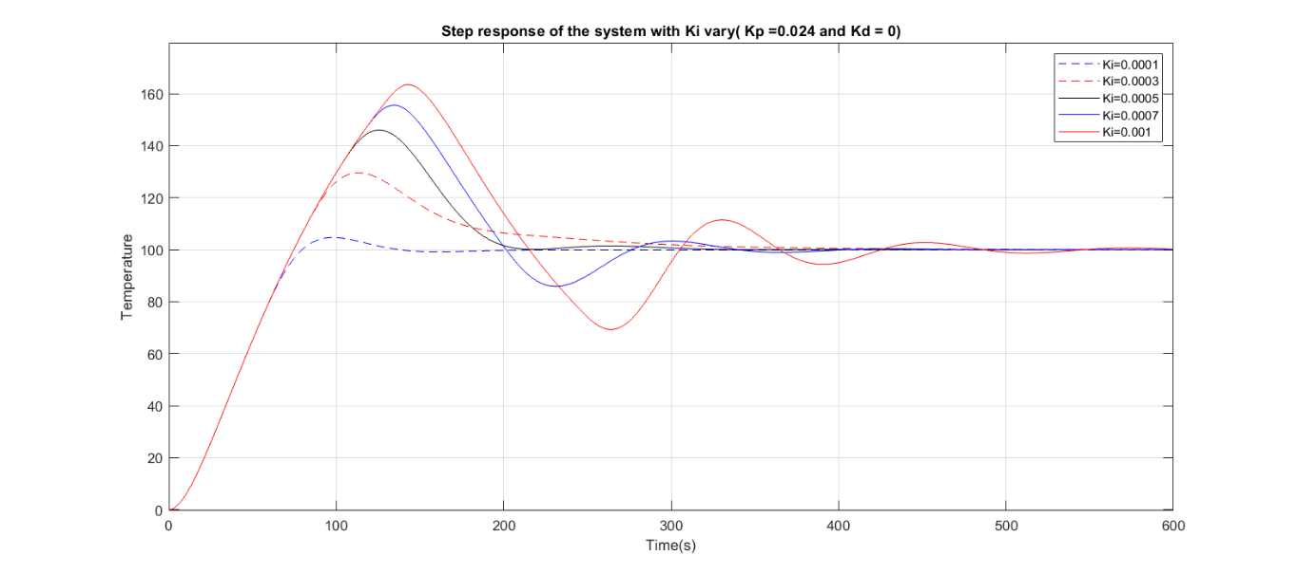

Figure 7: Step response of the system using PI controller

|  |  |  |  |  |  |  |
| --- | --- | --- | --- | --- | --- | --- |
| Ki | Overshoot  (%) | Steady State Error | Duration of Response | | | Duration of Steady State |
| 10% | 90% | Duration |
| 0.0001 | 4.72 | 0.054 | 13.85 | 67,83 | 53.98 | 121.36 |
| 0.0002 | 29.51 | -0.033 | 13.85 | 67.13 | 53.28 | 294.8 |
| 0.0003 | 45.99 | 0 | 13.85 | 67.1 | 53.25 | 197.2 |
| 0.0004 | 55.57 | -0.0017 | 13.85 | 67.1 | 53.25 | 371.63 |
| 0.0005 | 63.17 | -0.1782 | 13.87 | 67.22 | 53.35 | 530.14 |

* When Ki increase the POT and settling time increase drastically while that the rise time and steady state error remain stable especially the steady state error is not noticable.

### Surveying system with controller PD(Kp=0.024, Ki=0). Find overshoot, setting error, and transient time:

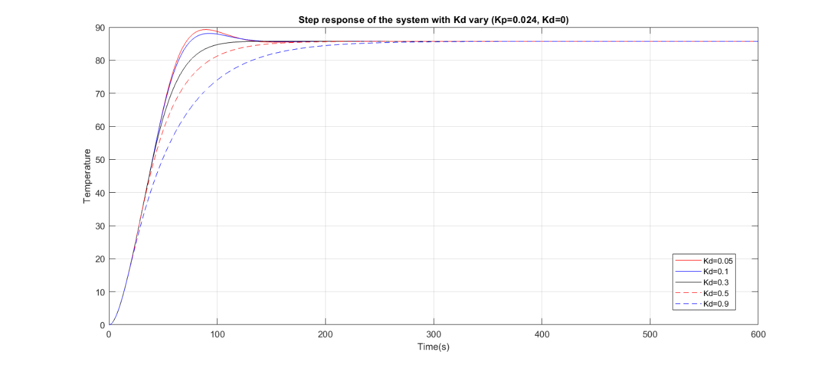

Figure 8: Step response of the system using PD controller

|  |  |  |  |  |  |  |
| --- | --- | --- | --- | --- | --- | --- |
| Kd | Overshoot  (%) | Steady State Error | Duration of Response | | | Duration of Steady State |
| 10% | 90% | Duration |
| 0.05 | 4.16 | 14.28 | 12.66 | 50.9 | 47.24 | 111.96 |
| 0.1 | 2.8 | 14.28 | 12.66 | 60.9 | 48.24 | 107.73 |
| 0.3 | 0 | 14.28 | 12.66 | 68.59 | 55.93 | 102.15 |
| 0.5 | 0 | 14.28 | 12.66 | 82.06 | 69.4 | 145.33 |
| 0.9 | 0 | 14.28 | 12.66 | 114.14 | 101.48 | 218.38 |

* When Kd increase the rise time and settling time increase while that the POT decrease to 0 and the steady state error remain the same.